**CONFIGURATION MODULE OF SMIT – “CONFIGURATION”**

Menu 1 : “ CONFIGURE”

1. Add academic years form

Home screen.

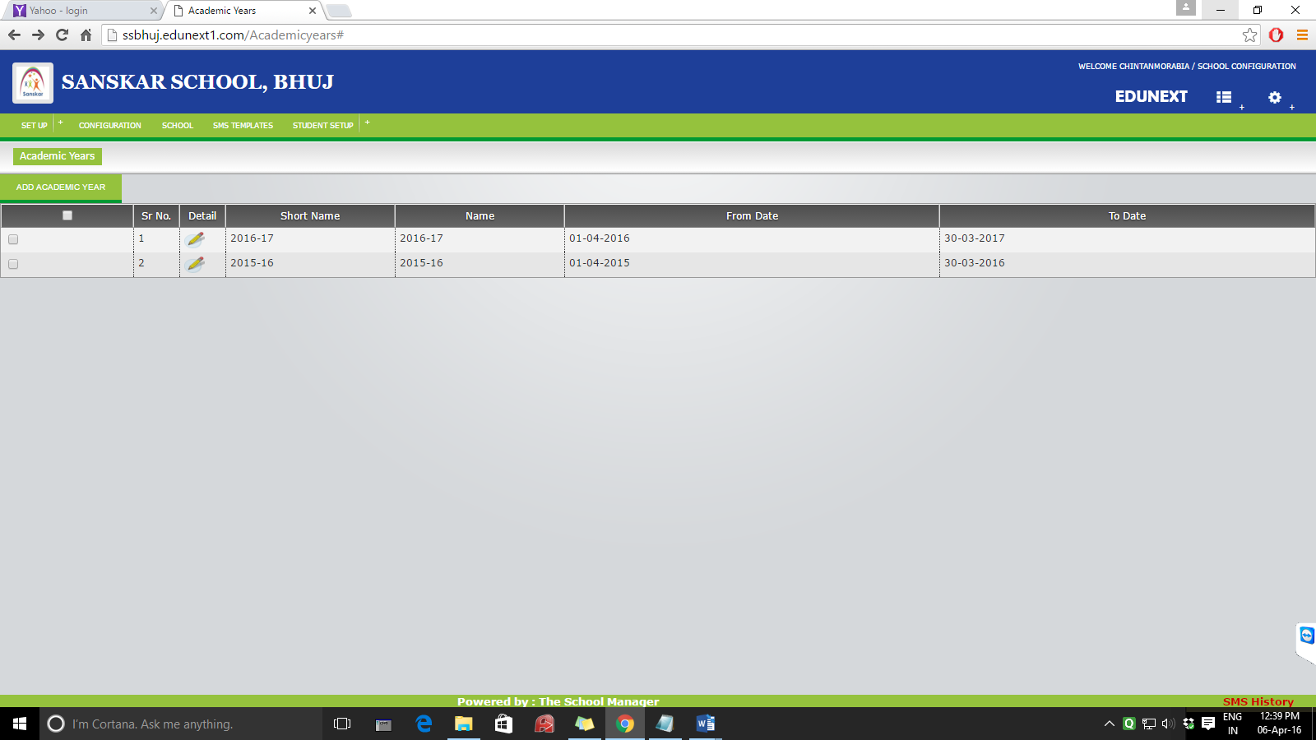

Form :

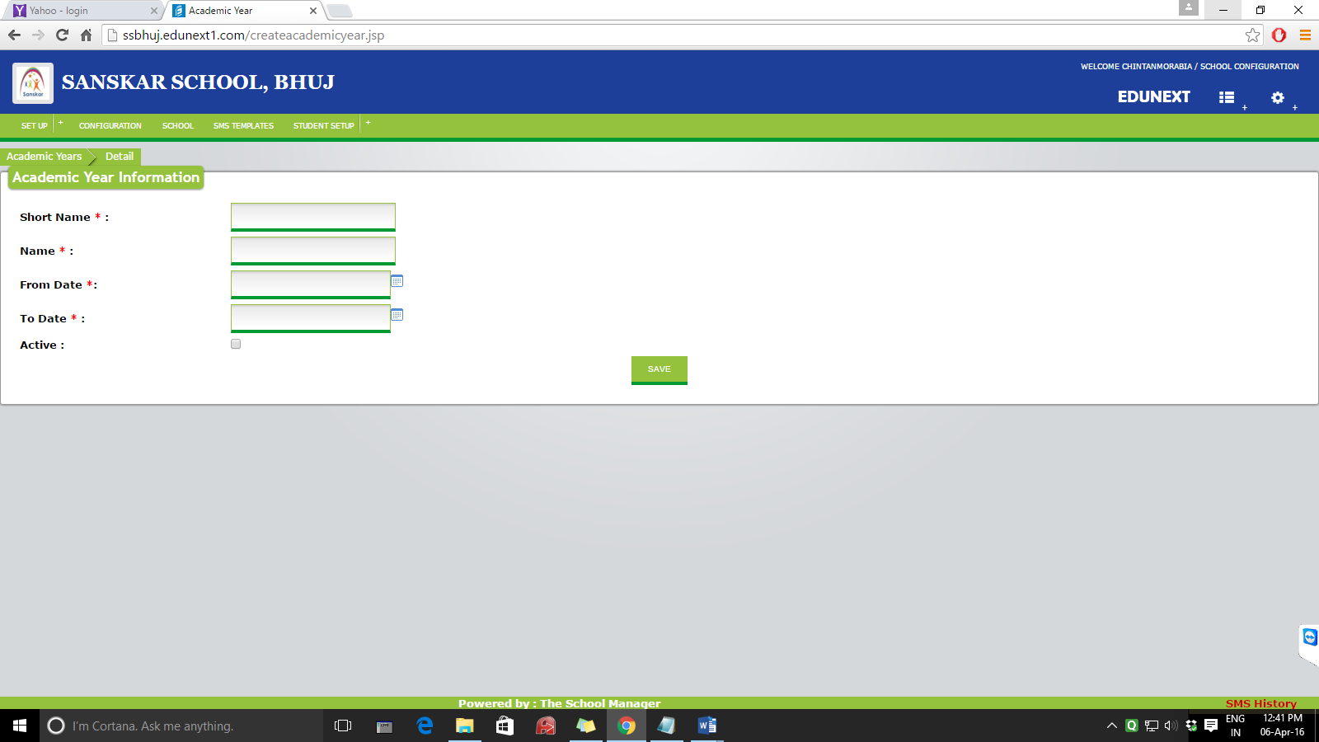

Active will be tick marked to the year which is currently going on.

1. Classes – adding classes

Home screen:

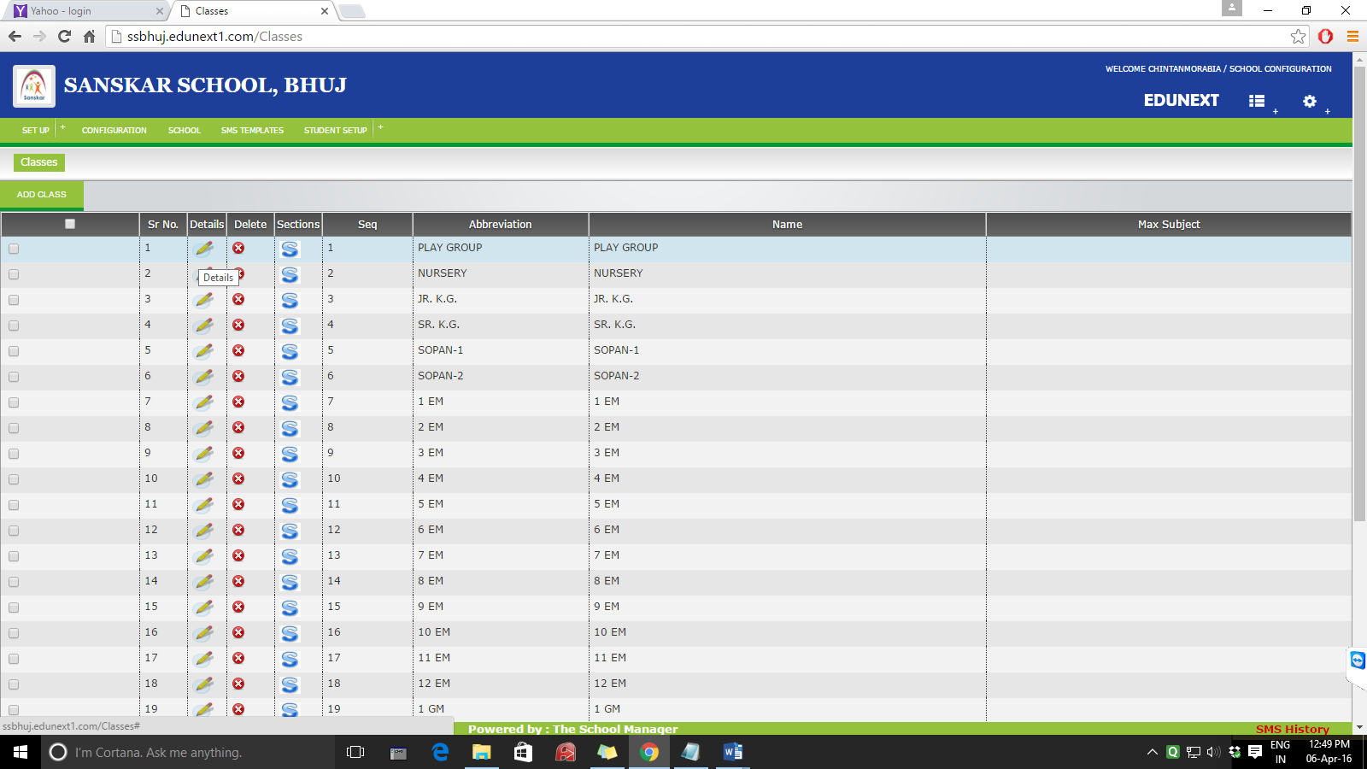

Details – this can edit the details of a particular class.

Section button – this can add a new section – A OR B OR C like this.

Add section home screen –

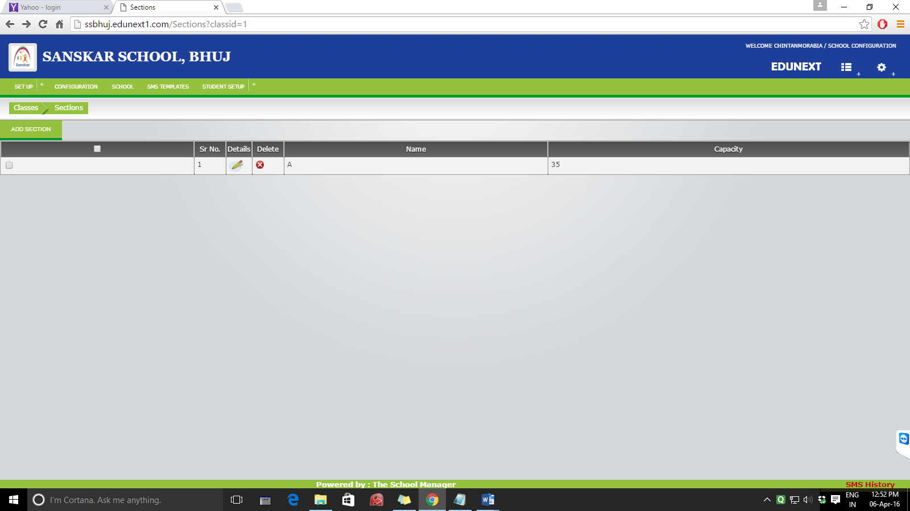

Add section form

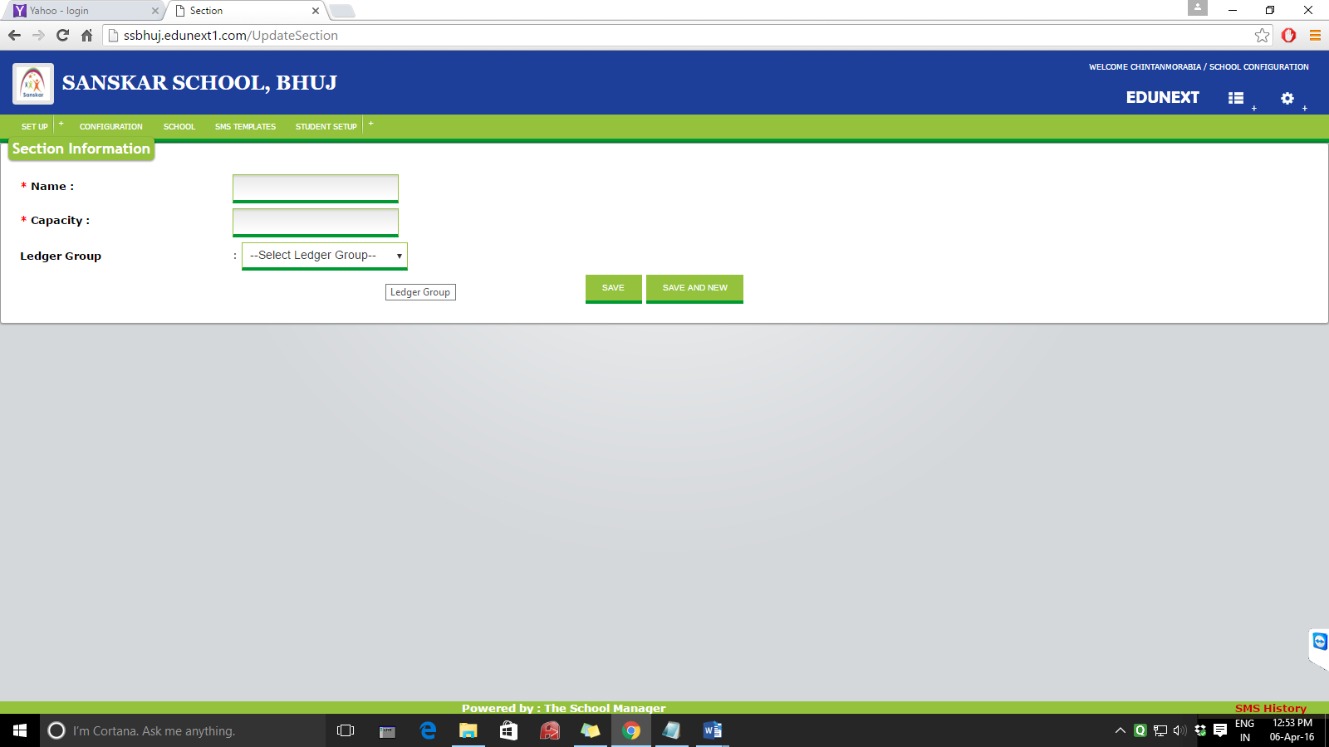

Ledger group not required. Capacity will indicate maximum student allowed in that particular section

Add class home screen :

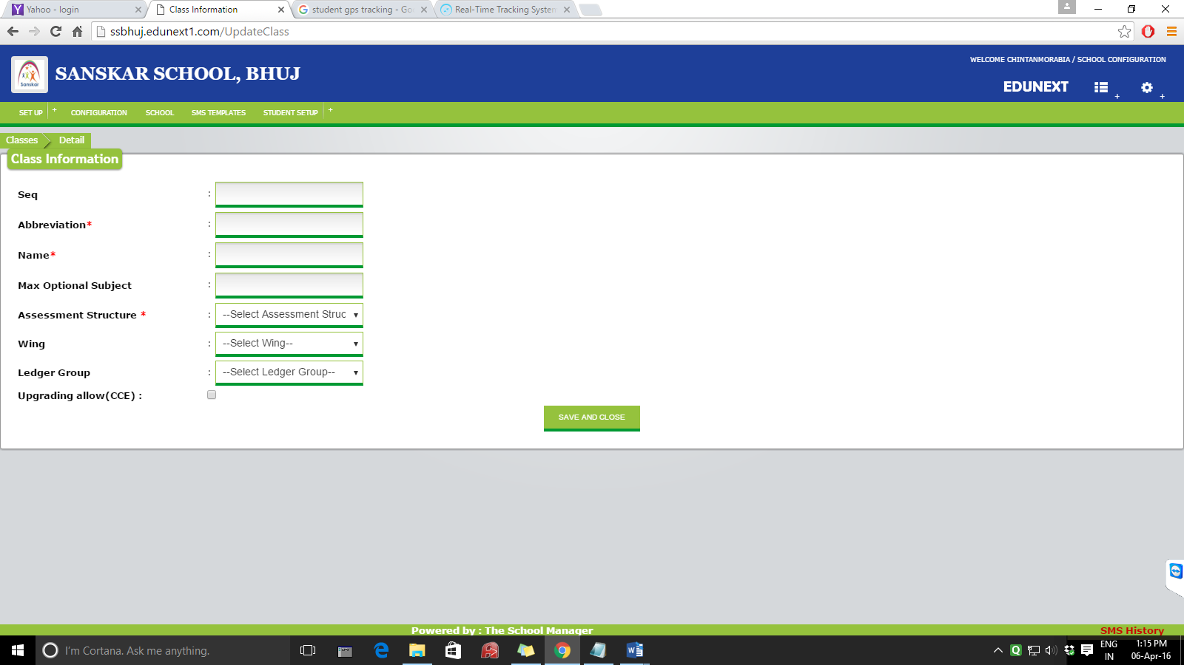

Seq – sequence view how it will be displayed.

Abbreviation –

Name –

Max optional subject -

Assessment structure –

Wing - replace this with “Course”. Currently BBA and BCA

Ledger group – not required.

Upgrading allow (CCE) – not required.

1. Designation form :

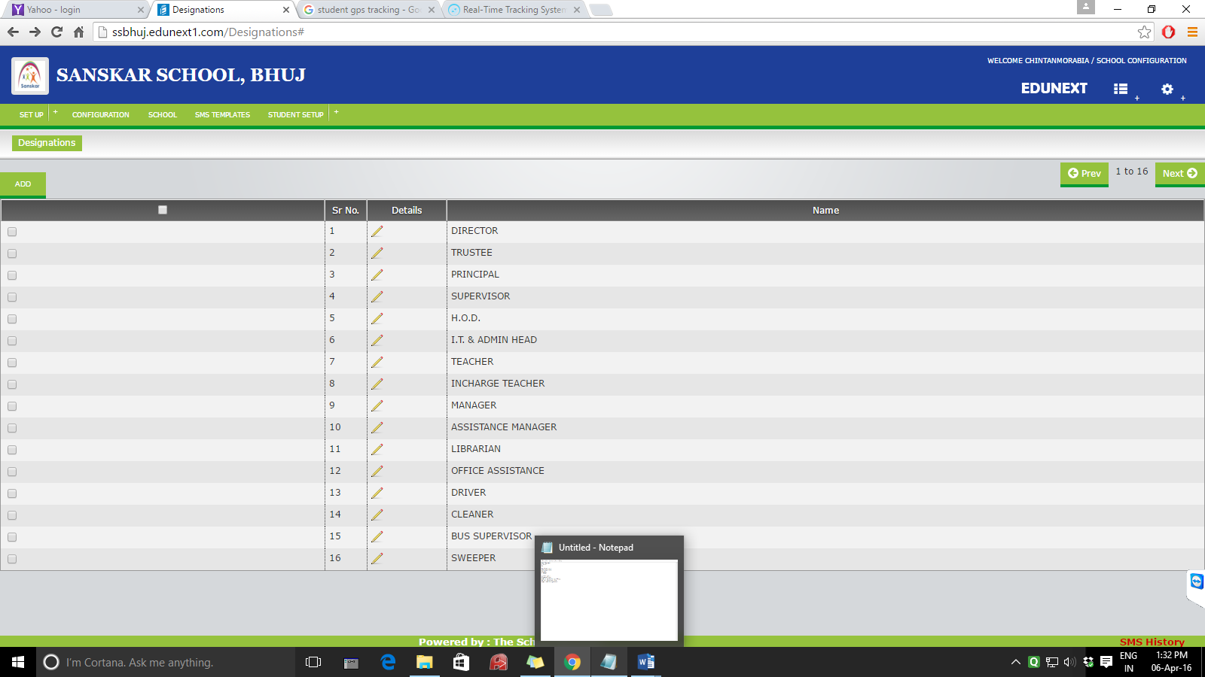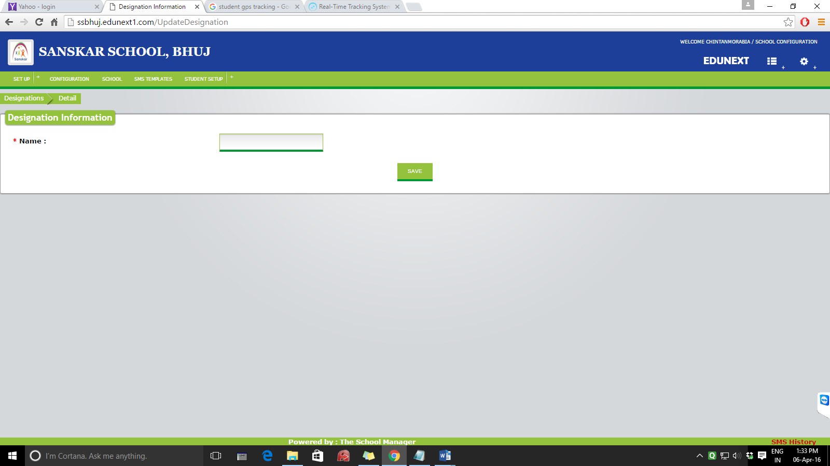

1. Add assessment structure : home screen

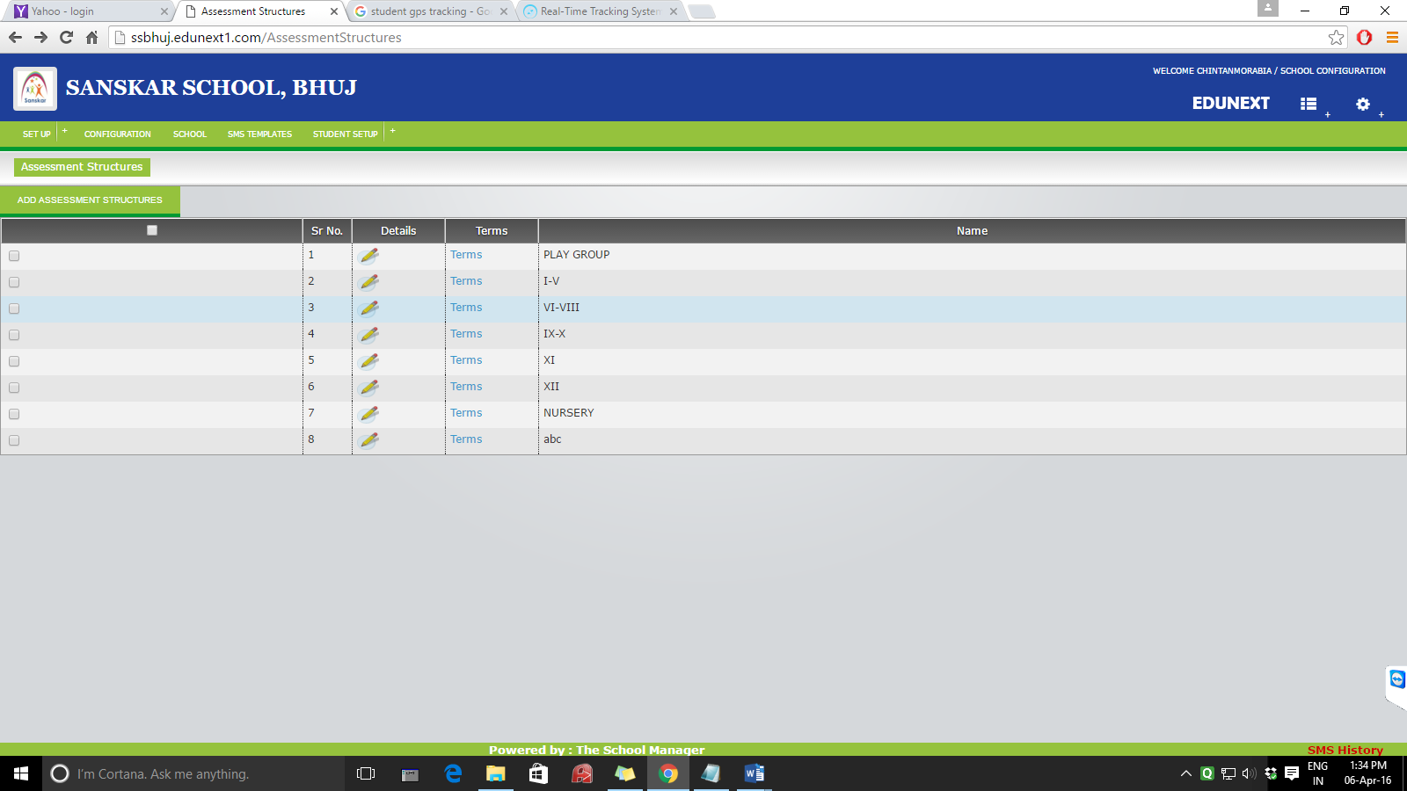

One column to be added here and i.e. course b.b.a. and b.c.a.

Delete option column should also be there

Adding up assessment structure :

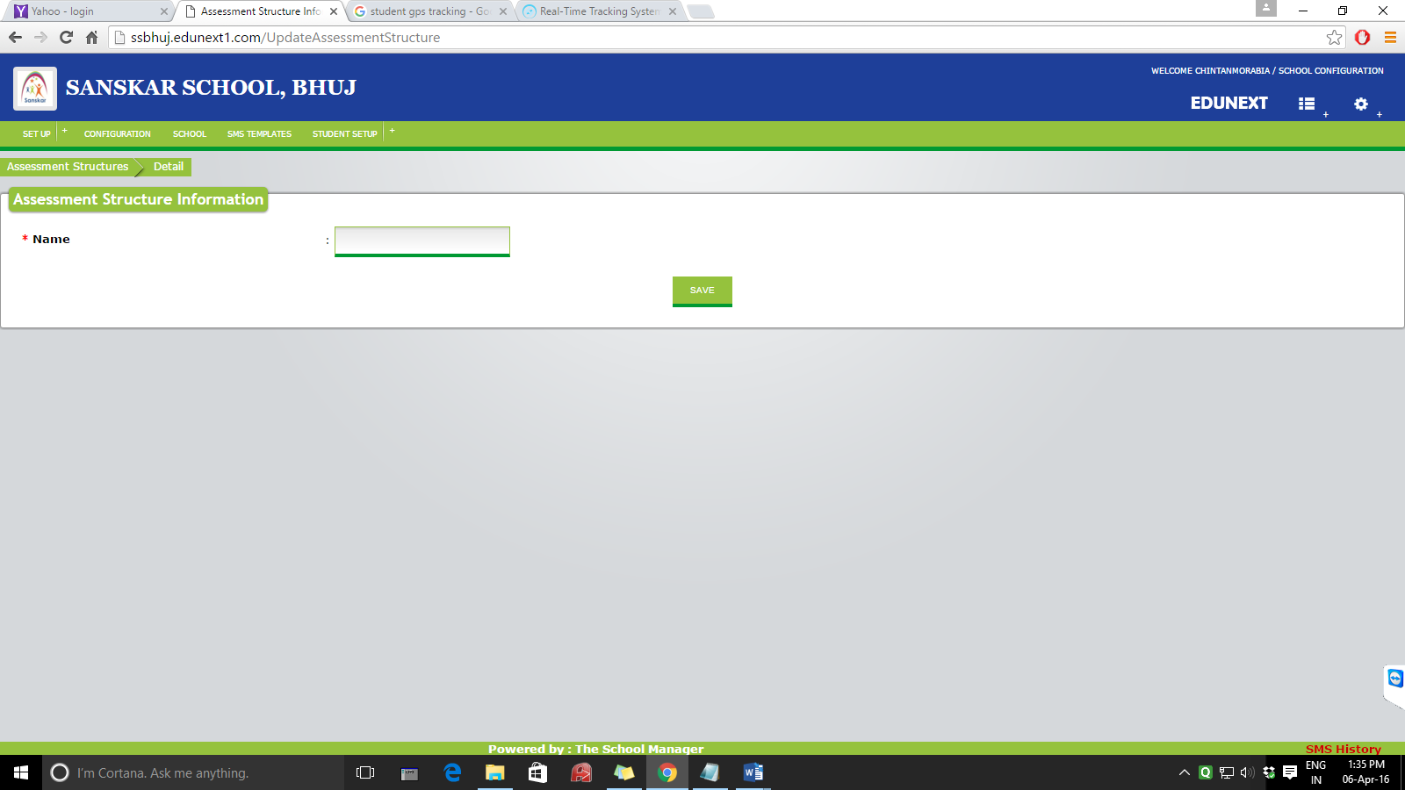

We will require 3 fields here.

Course: combo

Name:

Assessment marks :

Following screen will be displayed once we click terms :

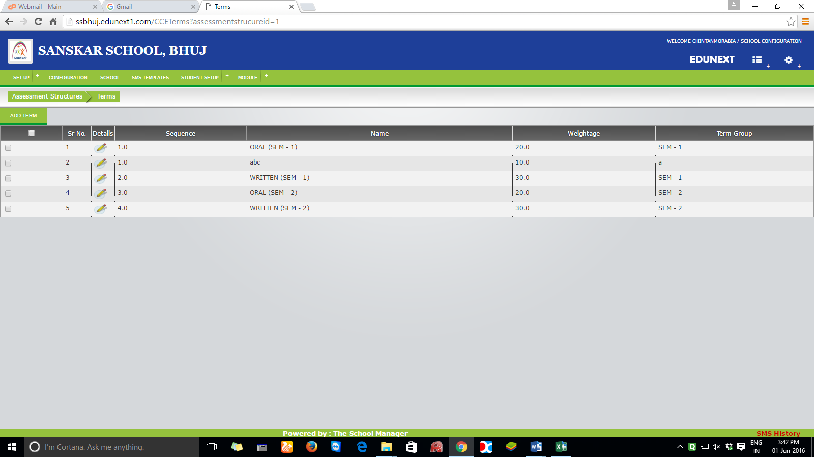

Delete option column should also be there

Adding up a new term :

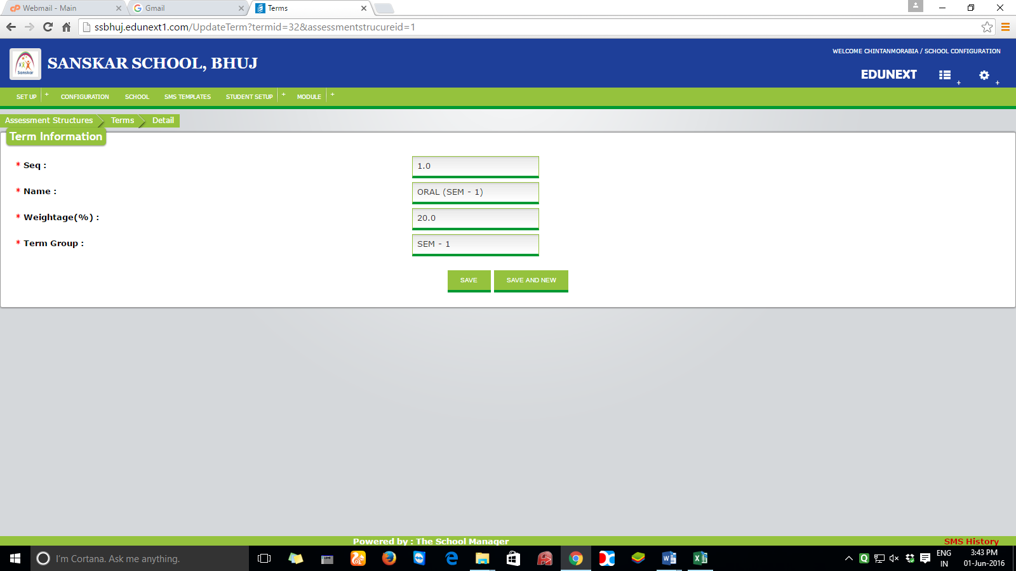

Instead of weightage in % it should be in marks. Term group will not be there.

1. Subjects

This form is for allocating subjects in a particular semester and its details

Homescreen:

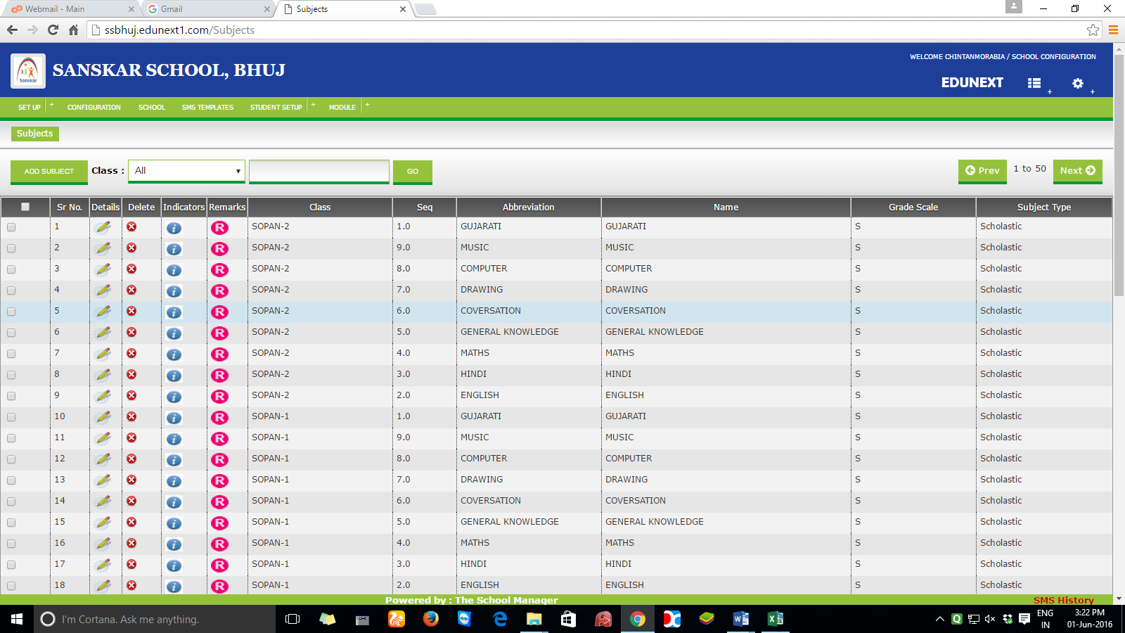

Add subject button :

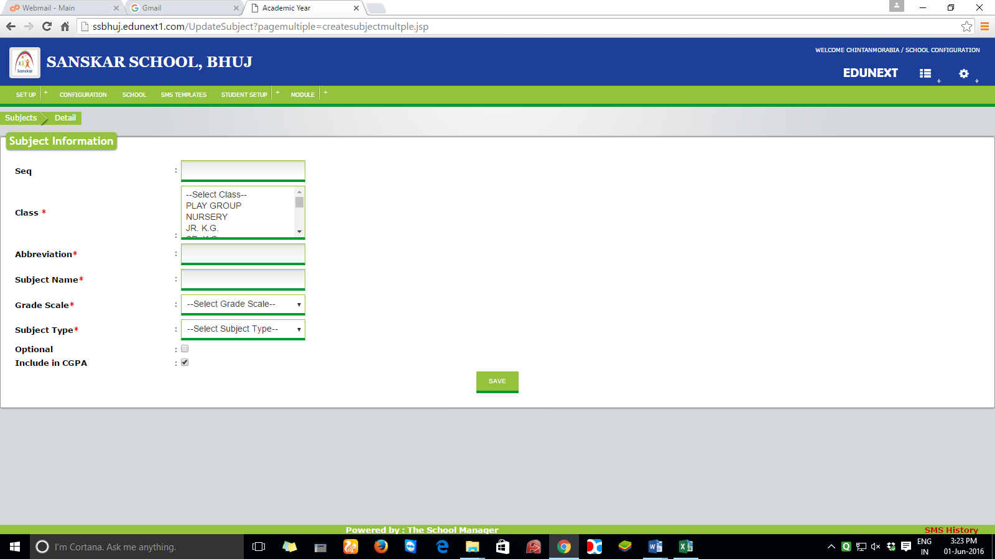

Fields required as per below mentioned details :

Seq :num

Course :combo

Sem :combo

Subject code:text

Subject name:text

Assessment type:COMBO

University Internal marks:number

Minimum passing marks:number

1. Periods : this for is for adding the periods – home screen

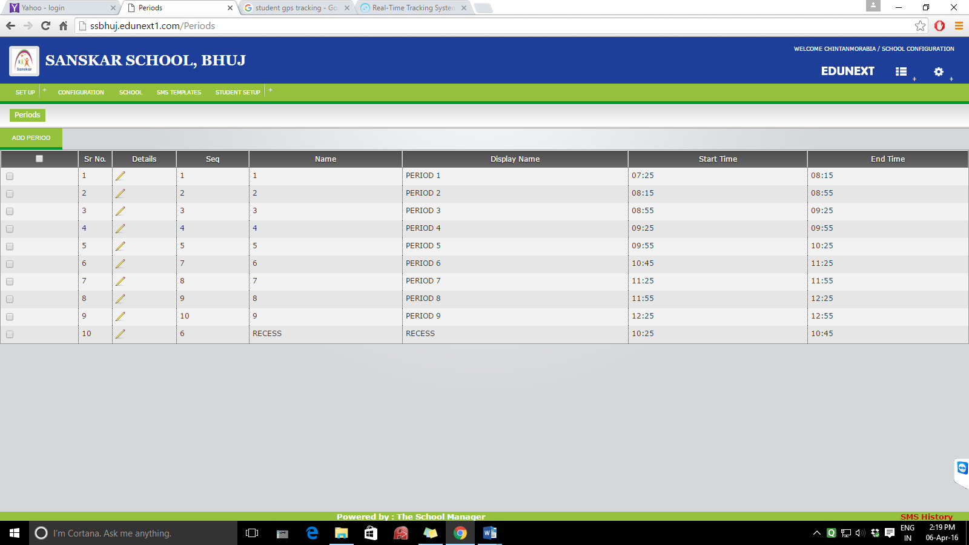

Add new period:

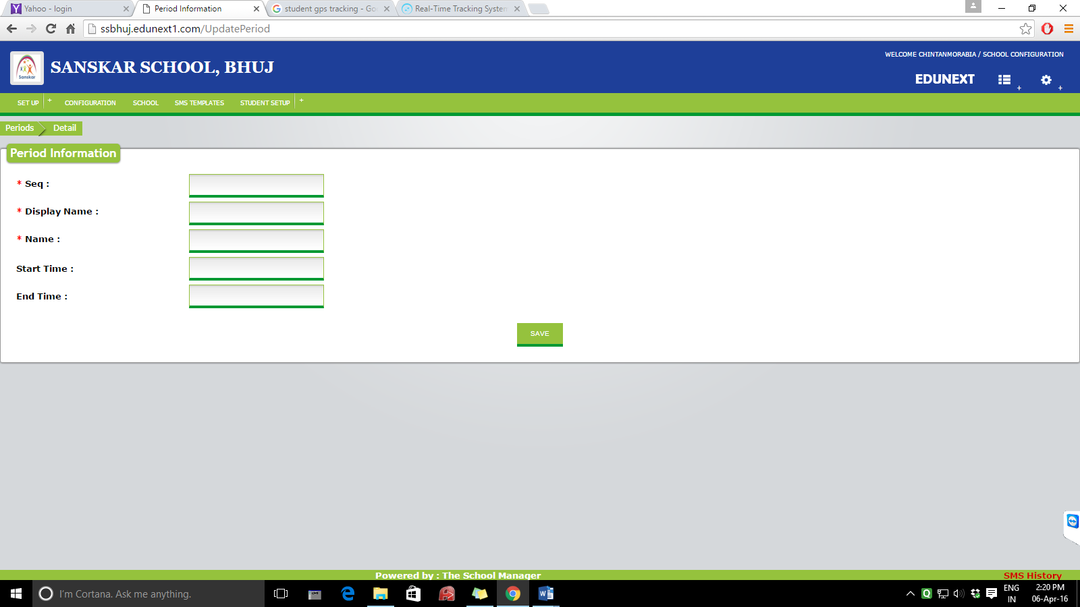

1. Documents : Dash board and adding up a new document into document list :

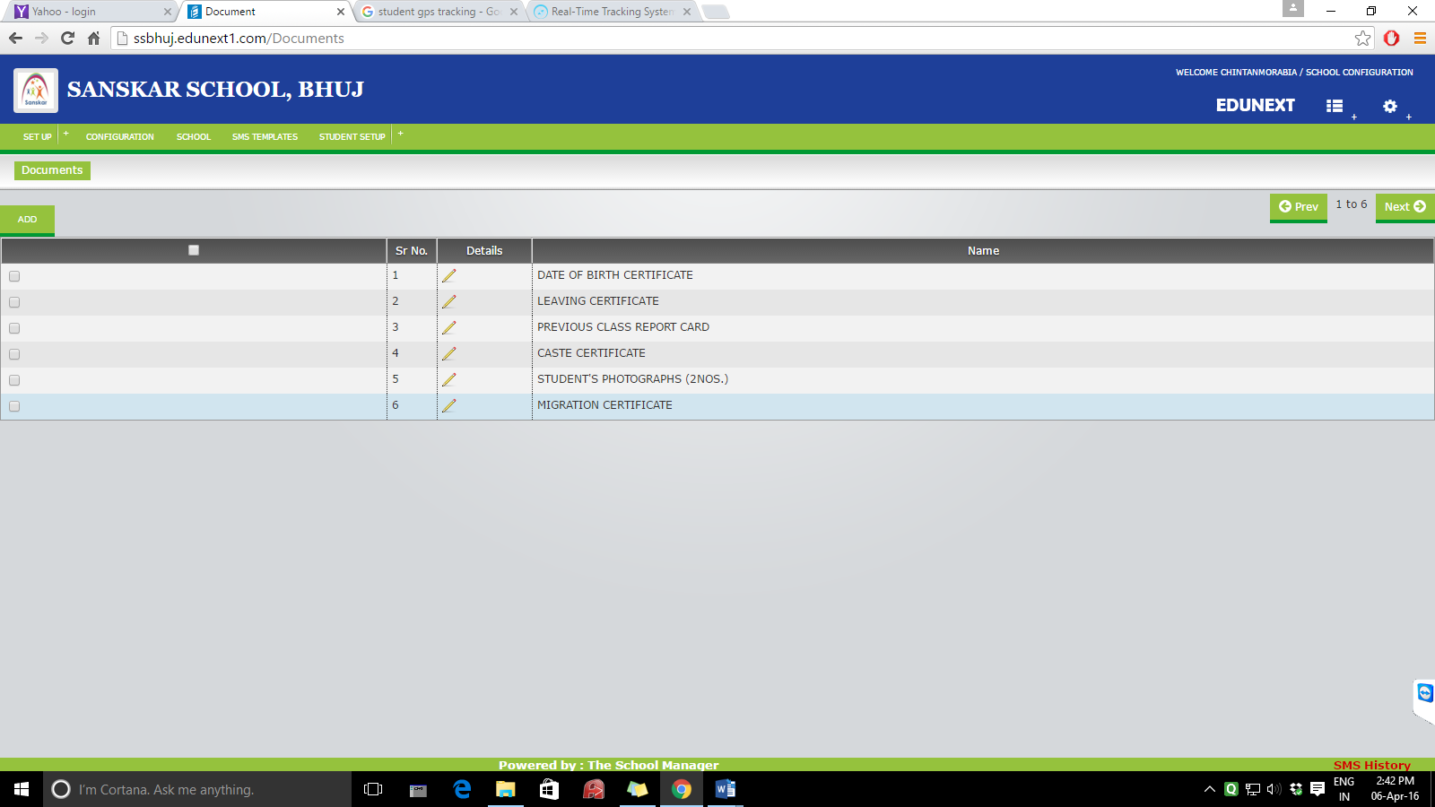

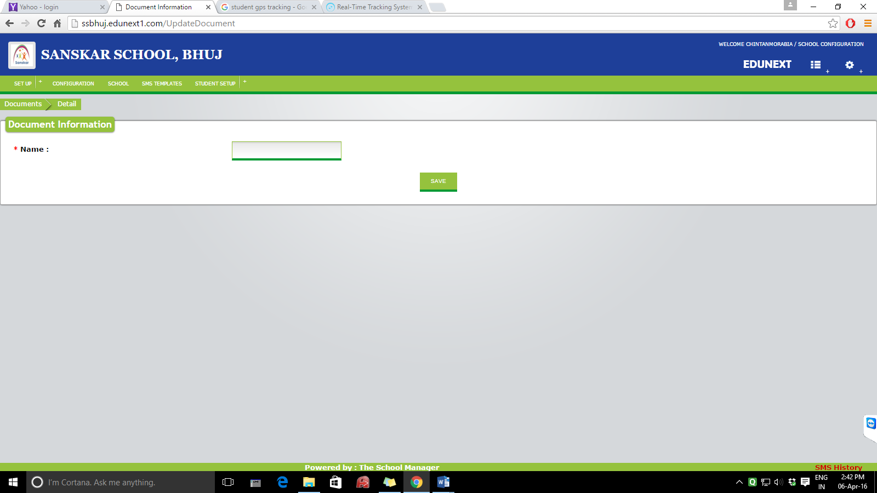

1. Event calendar type :

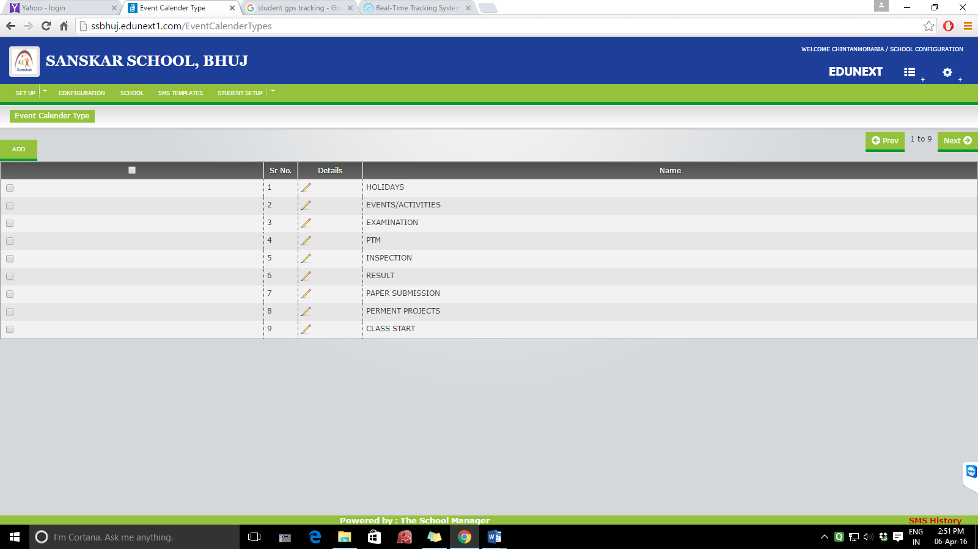

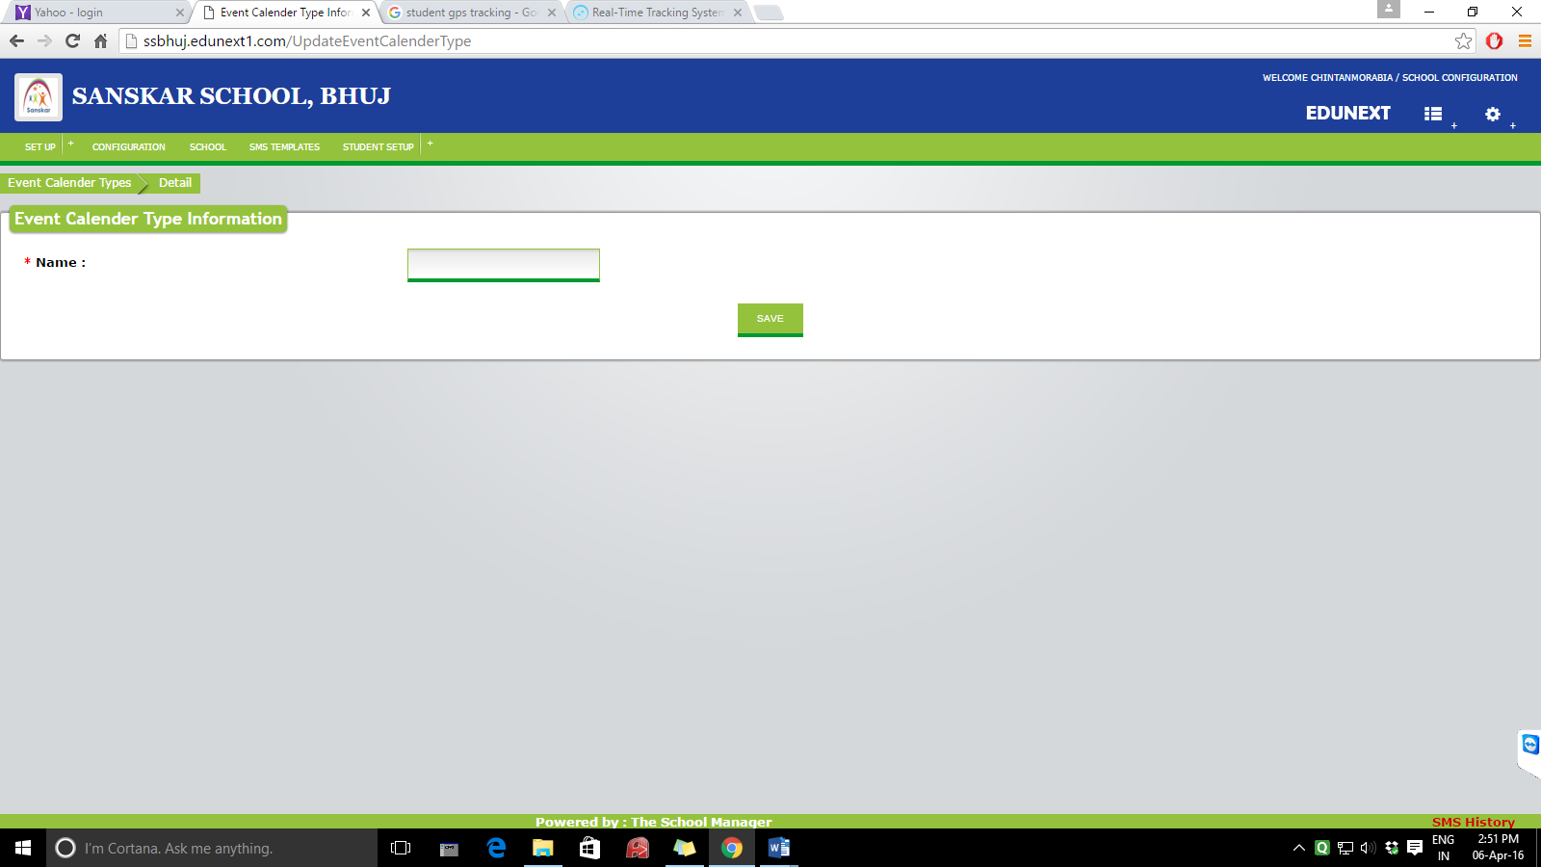

8. Wings – replace with “courses”

Dashboard:

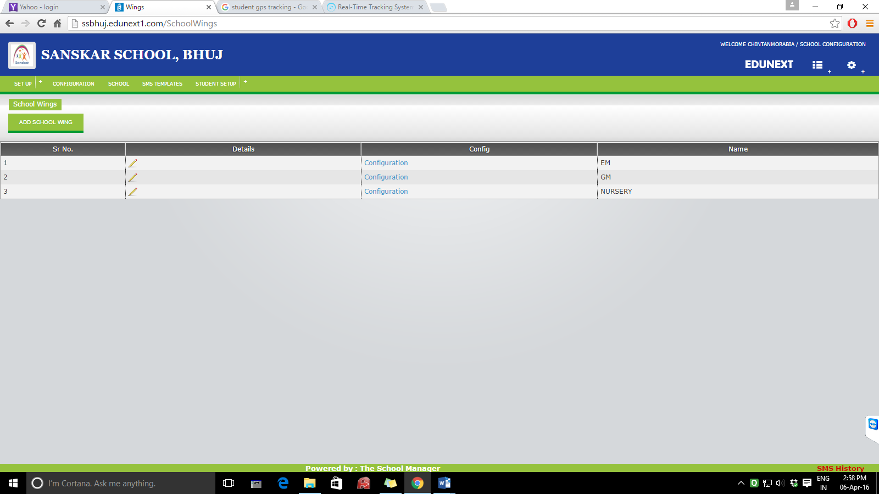

Add course form:

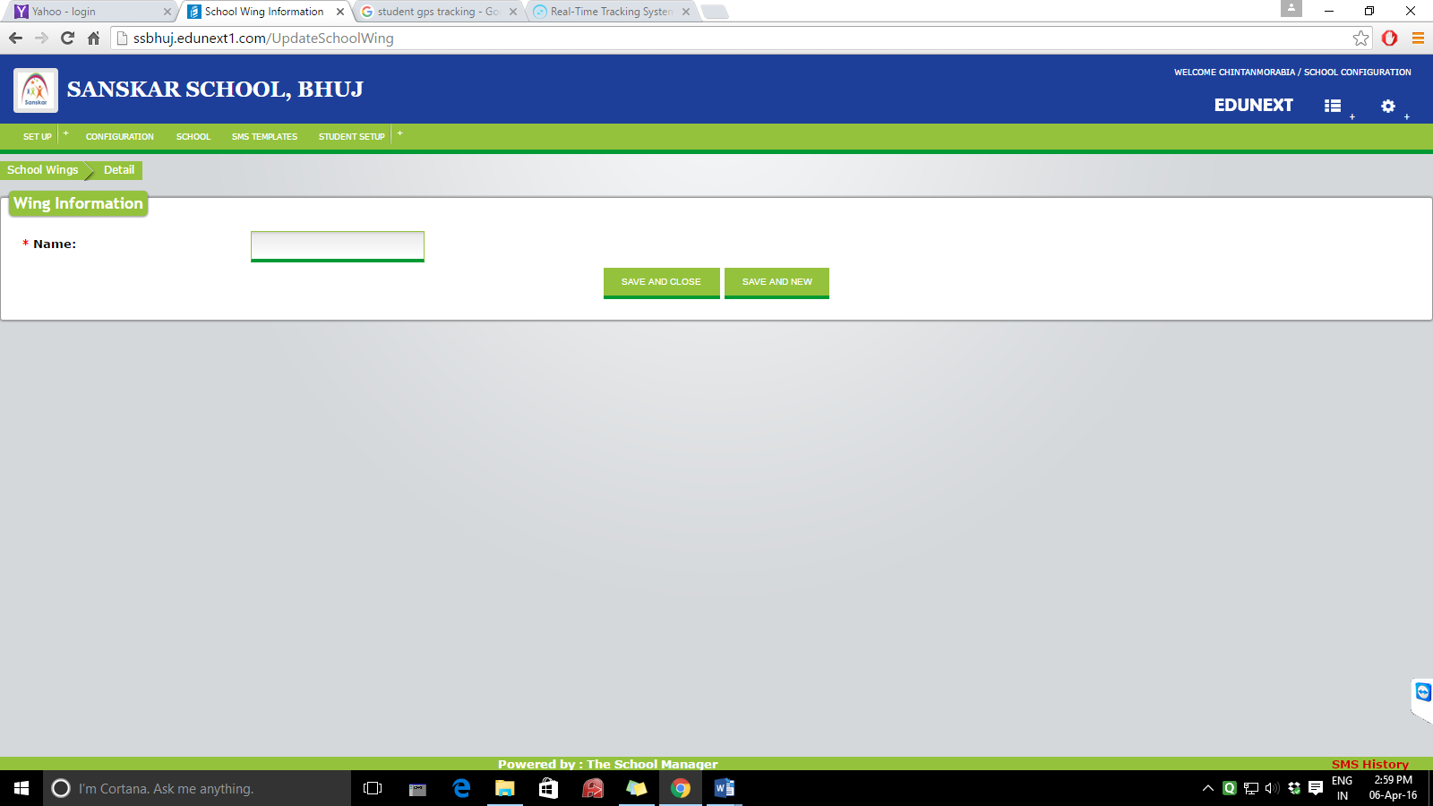

**MENU 2 : COLLEGES**

**This menu will specify different colleges under our trust and information regarding the same.**

**Dashboard will list the already saved colleges.**

**Add college information form:**

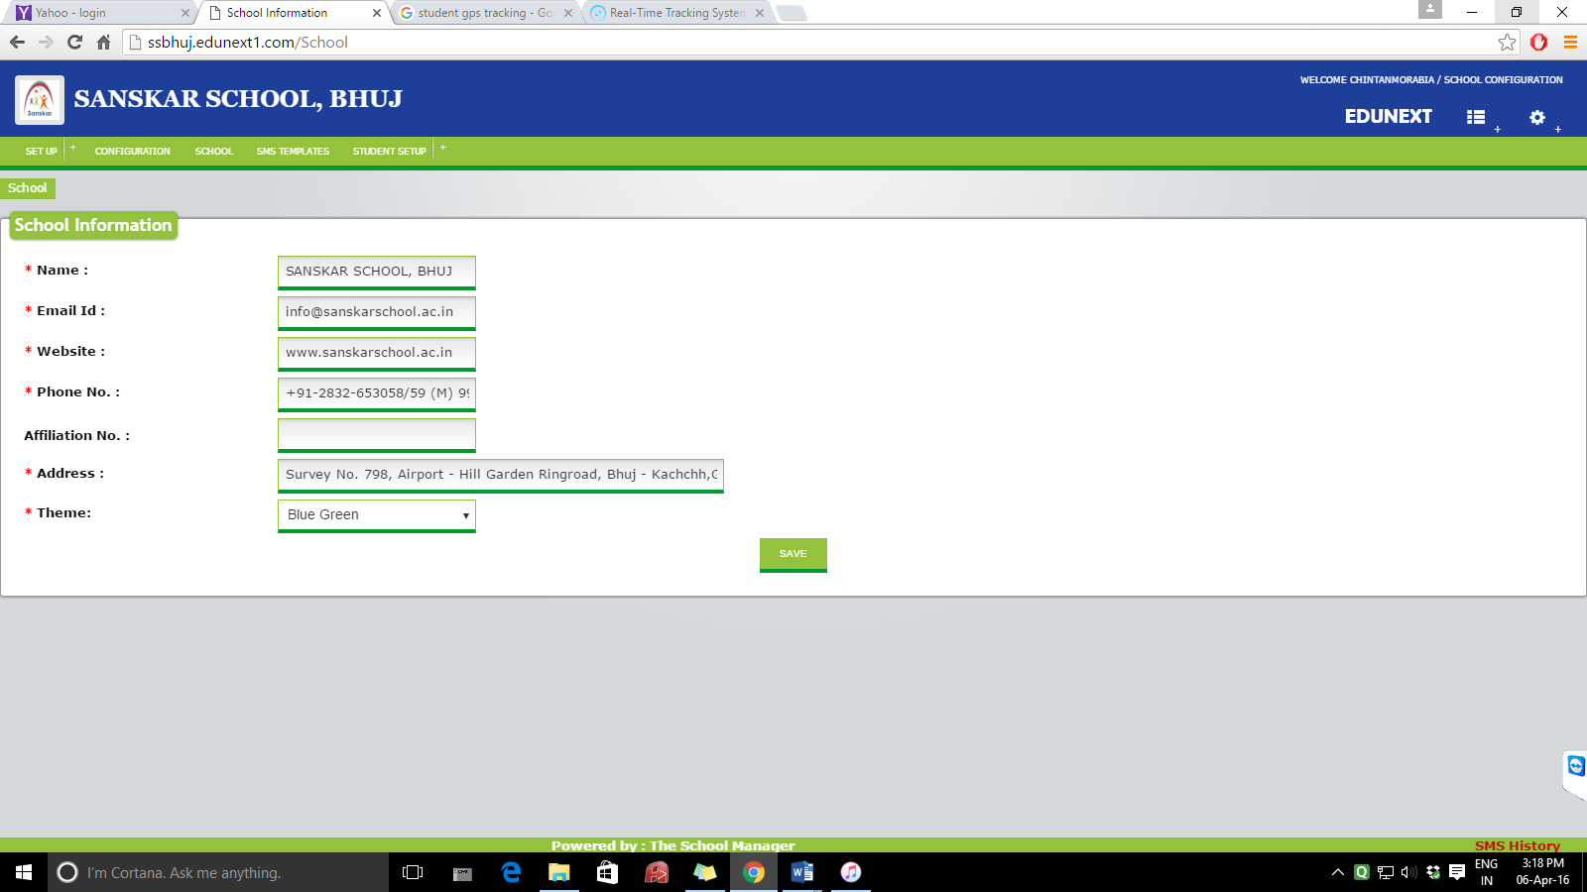

**MENU 3 : SMS TEMPLATES**

**HOME SCREEN**

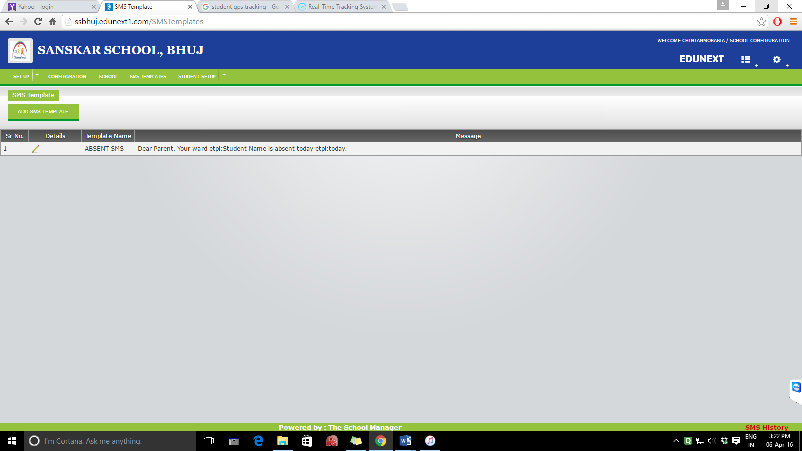

ADD SMS TEMPLATE

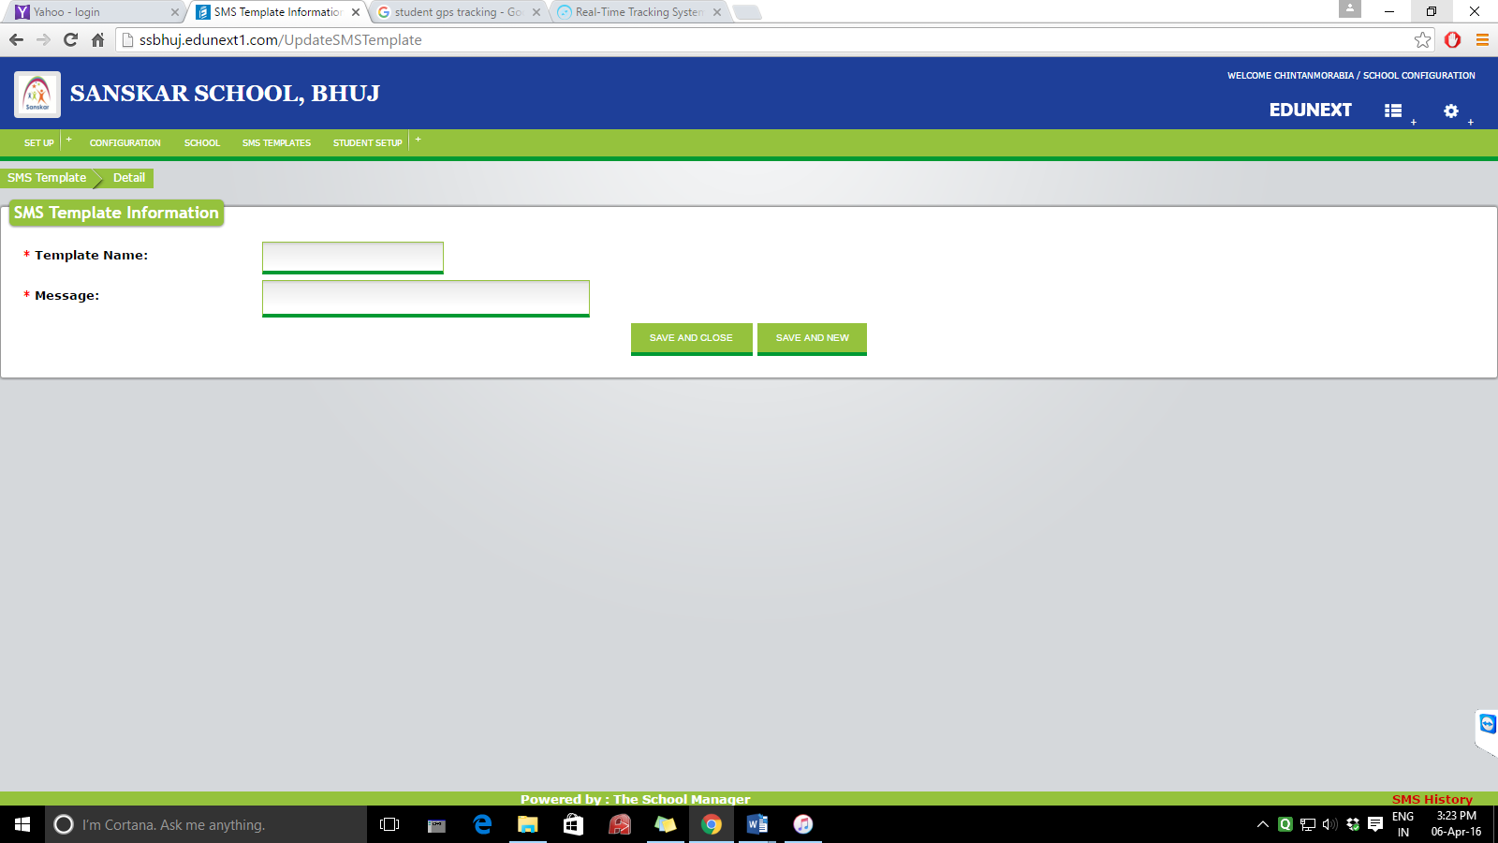

**MENU 4 : STUDENT DATA SETUP**

1. Occupation of father :

Home screen:

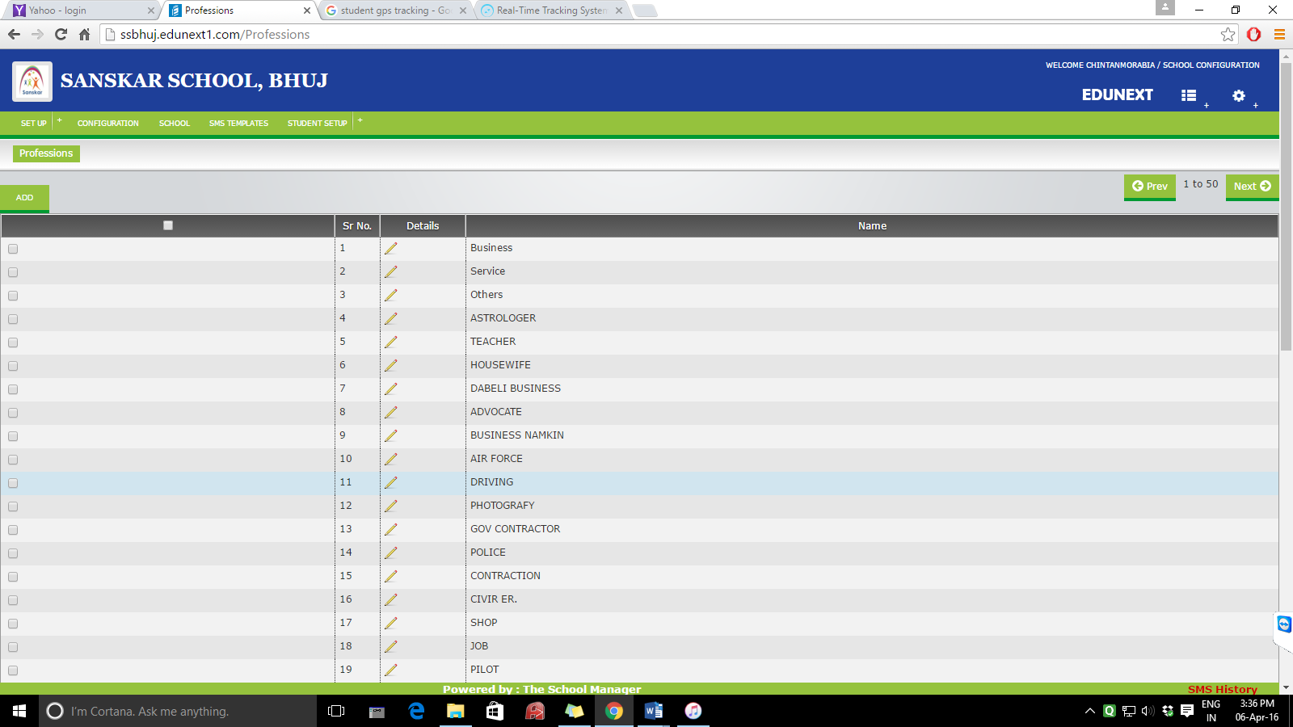

Add an occupation :

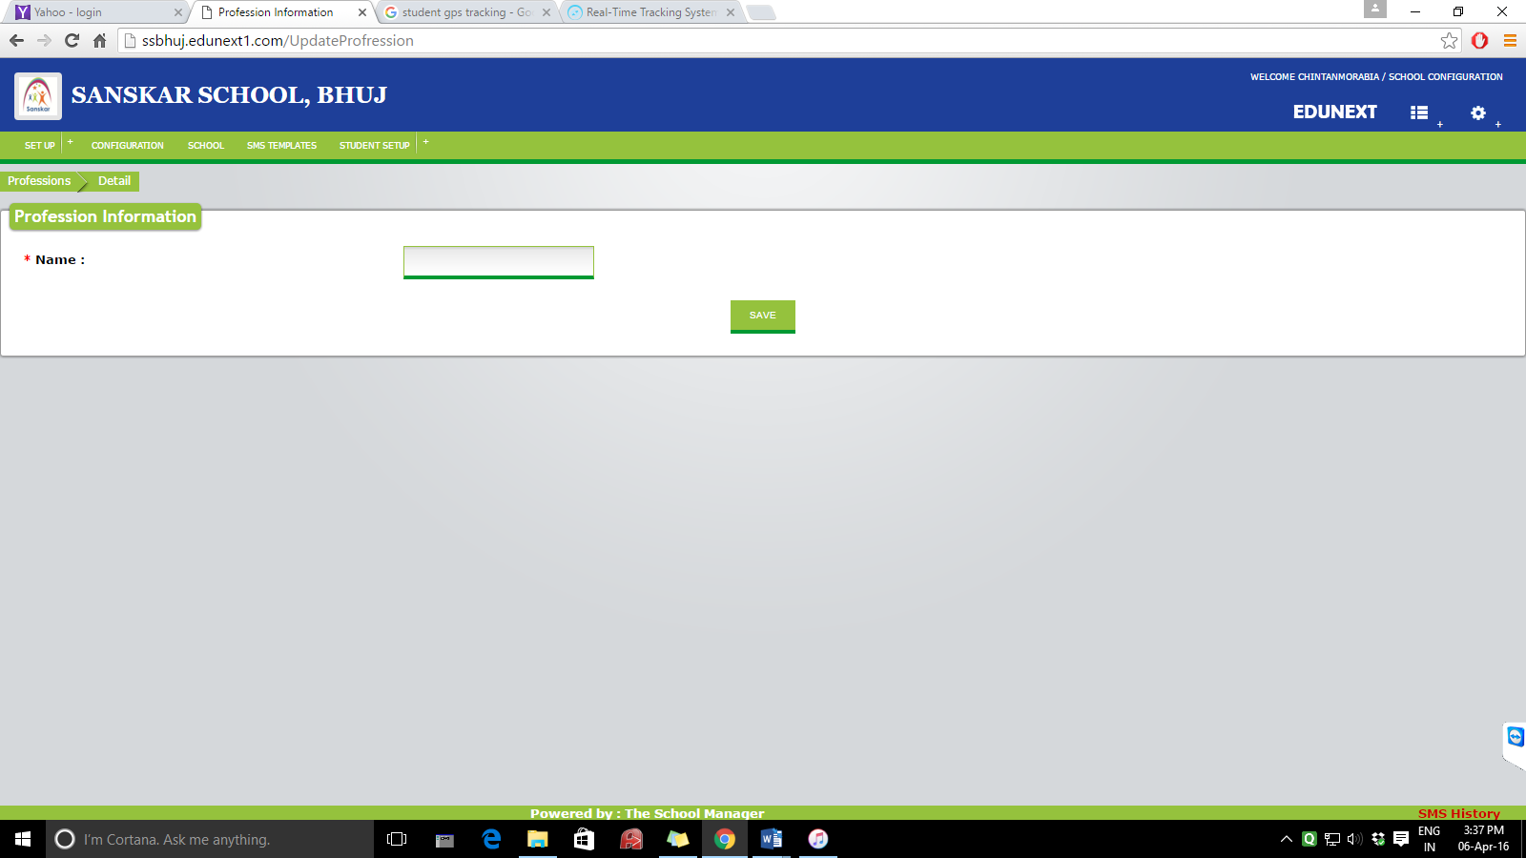

1. QUALIFICATION

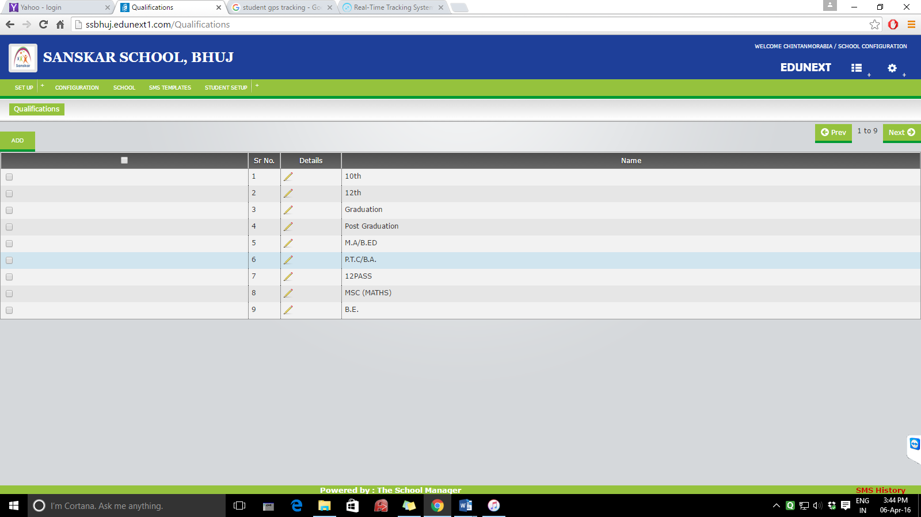

ADD:

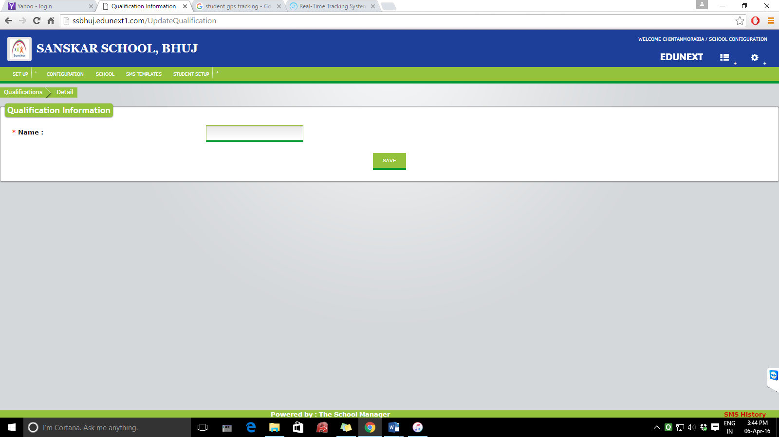

1. Salutations

Home screen

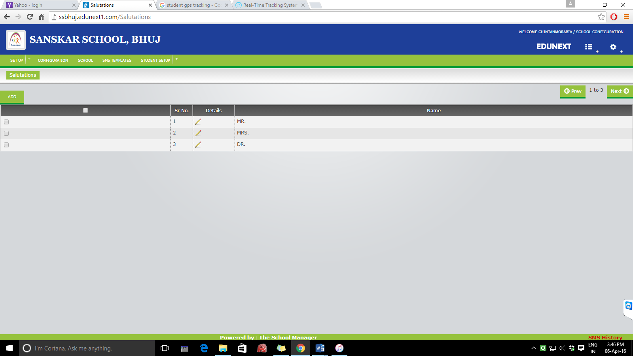

Add:



1. Categories

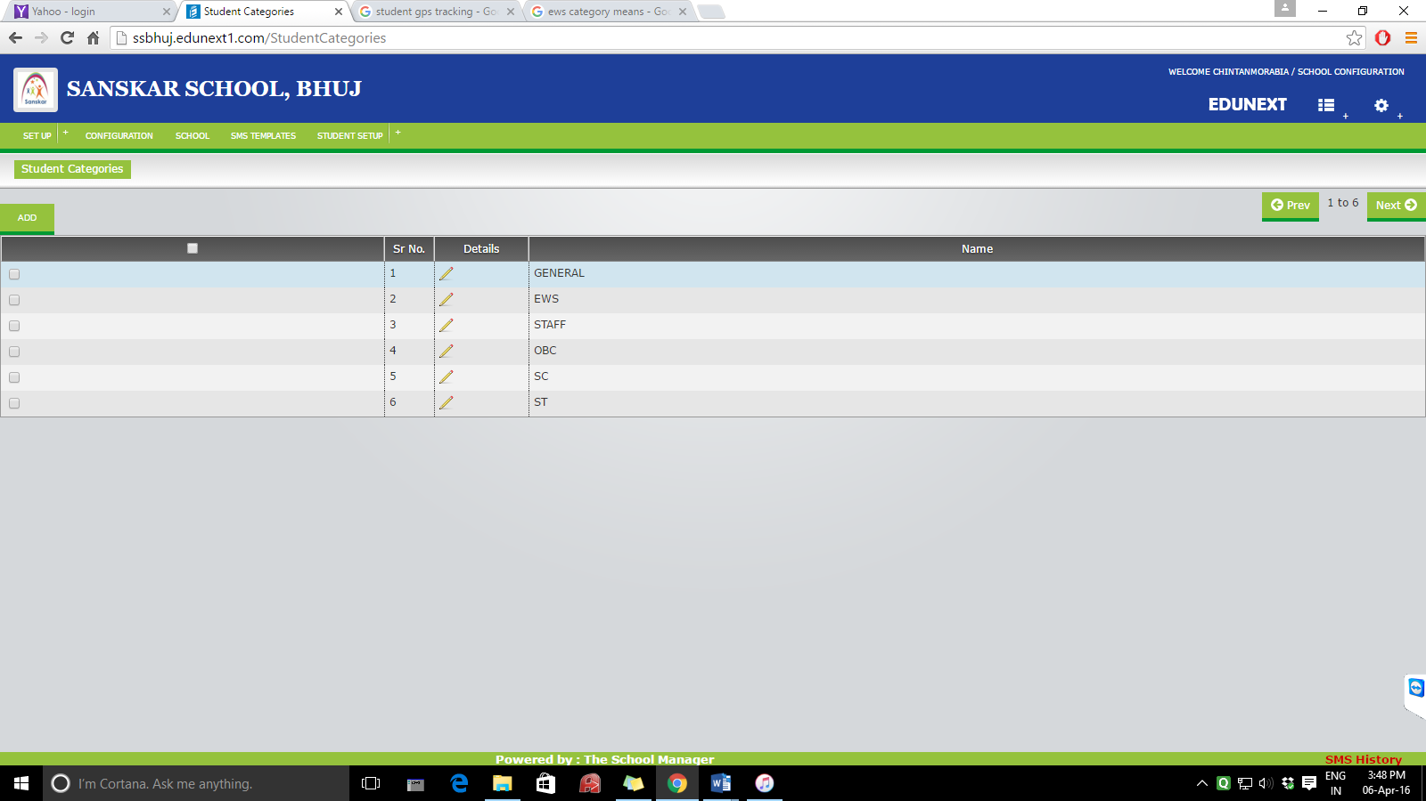

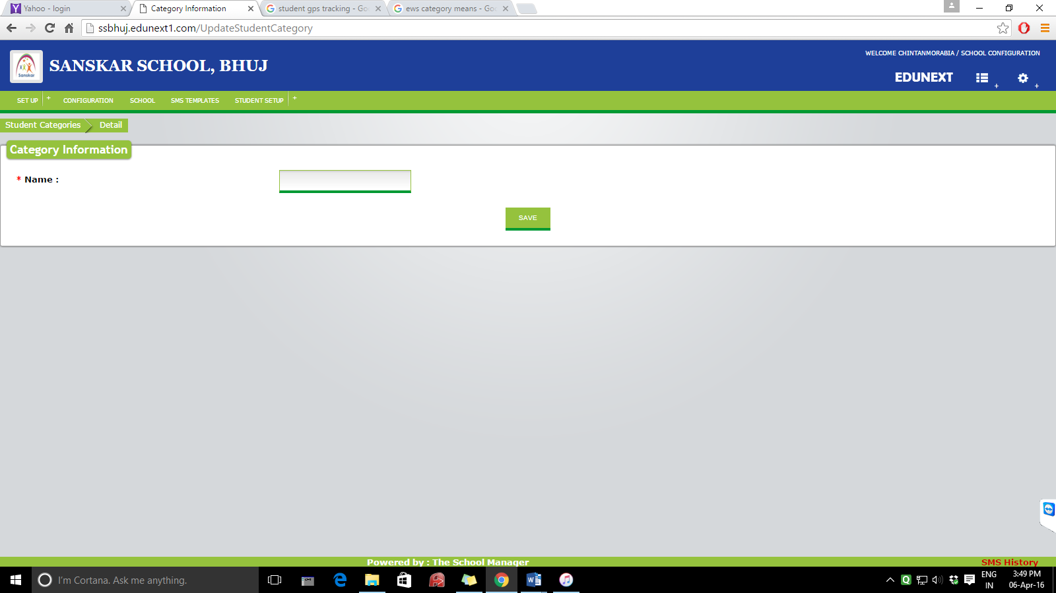

1. Religion

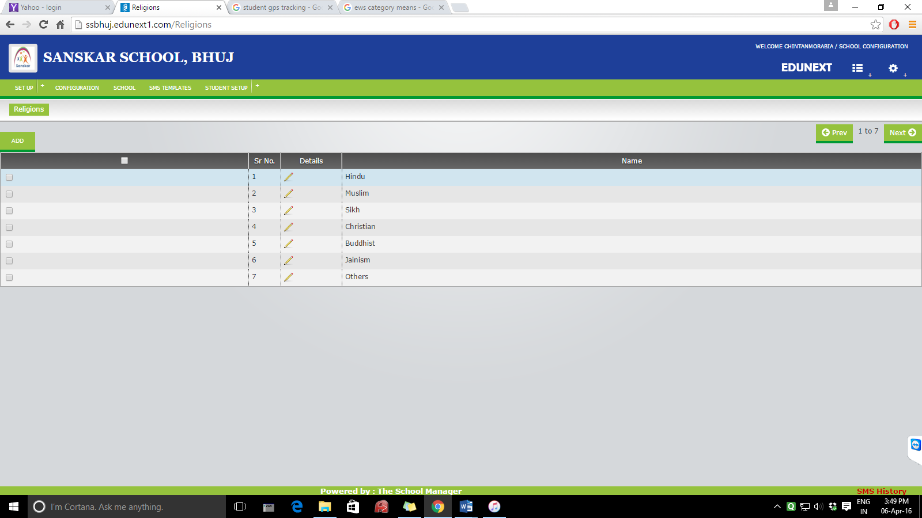

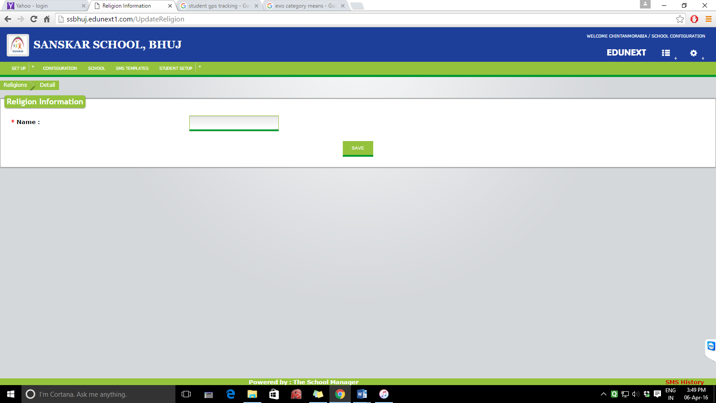

1. Sms senders :

